Sudip Lamichhane — WP3 Individual Contribution & Progress Report
PRT661 – Data Science Practice | Dan6 Theme 2 | Modelling, Forecasting and Verification
Student | ID | WP3 role | Workstream
Sudip Lamichhane | S388085 | Data Acquisition & Correction Handling Lead | SARIMA/SARIMAX · live weather update · AEMO secondary benchmark

Evidence note This document is aligned to the verified 14 September Stage 3 run. Contribution descriptions preserve the role boundaries in the existing WP3 documents and describe shared integration as team work rather than assigning the final pipeline to one person.

1. Allocated WP3 responsibility
Sudip’s Stage 3 work connects source semantics to the statistical and external-benchmark parts of modelling. The assigned candidate family is SARIMA/SARIMAX. The same workstream controls how a genuine seven-day weather forecast may update Model B and how AEMO pre-dispatch information is compared without being mislabelled as the same forecasting target.
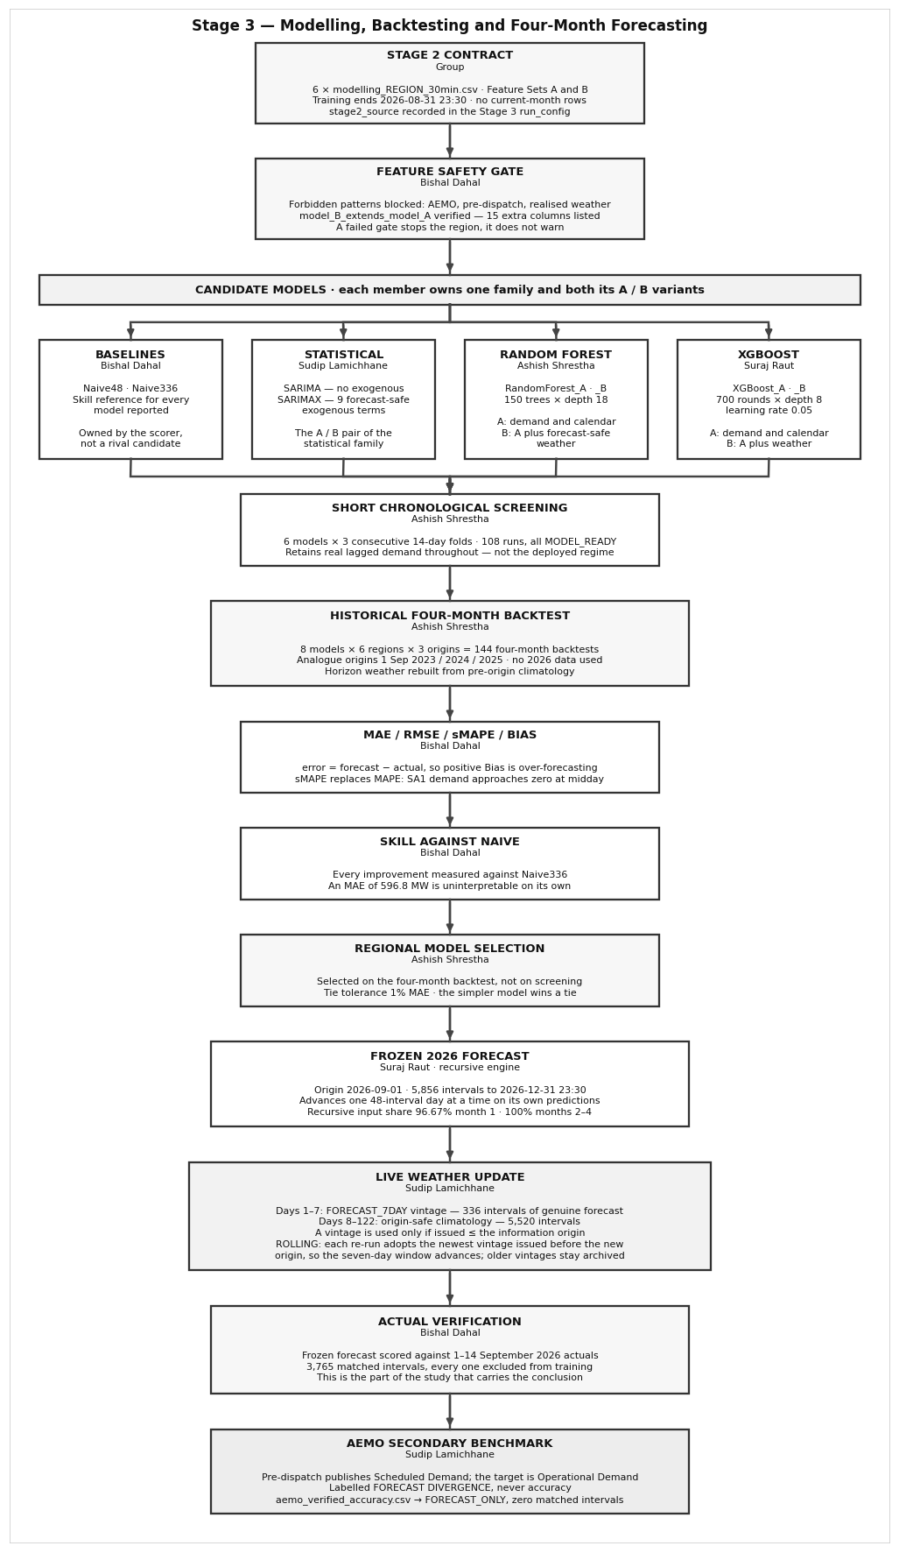
Figure 1. Sudip-owned blocks: the SARIMA/SARIMAX statistical family, live weather update and AEMO secondary benchmark.

2. Why the statistical family was retained
Assessment 1 committed the project to a three-tier comparison: a seasonal baseline, a statistical time-series model and machine-learning models. SARIMA therefore remains important even if it does not win. It tests whether a compact autoregressive/seasonal model can capture the daily structure without a large engineered feature set. SARIMAX adds a small exogenous set containing only future-known or forecast-safe variables.
Model | Design | Reason retained
SARIMA | ARIMA structure with daily seasonal period s=48; bounded recent training window | Statistical benchmark promised in Assessment 1 and interpretable seasonal comparator.
SARIMAX | Same state-space structure plus compact future-safe exogenous inputs | Tests whether weather/calendar context helps a statistical model without leaking future actuals.

Runtime/stability control A full 82k-interval seasonal state-space fit is impractical for repeated regional backtests. The production code records a bounded recent training window, convergence status and exogenous-support filtering instead of silently abandoning the statistical tier.

3. Statistical backtest outcome
Region | Model | MAE | RMSE | sMAPE | Ready | Warn | Fail
NSW1 | SARIMA | 1330.2 | 1658.3 | 19.12% | 2 | 1 | 0
NSW1 | SARIMAX | 2105.4 | 2537.2 | 29.16% | 0 | 3 | 0
QLD1 | SARIMA | 941.2 | 1241.5 | 15.80% | 2 | 1 | 0
QLD1 | SARIMAX | 1180.7 | 1492.1 | 21.55% | 0 | 1 | 2
SA1 | SARIMA | 373.0 | 539.8 | 37.52% | 3 | 0 | 0
SA1 | SARIMAX | 373.5 | 459.7 | 37.63% | 0 | 2 | 1
TAS1 | SARIMA | 154.6 | 180.1 | 14.38% | 3 | 0 | 0
TAS1 | SARIMAX | 160.8 | 200.1 | 14.99% | 0 | 2 | 1
VIC1 | SARIMA | 1010.9 | 1251.0 | 22.99% | 3 | 0 | 0
VIC1 | SARIMAX | 1147.2 | 1369.4 | 25.76% | 0 | 1 | 2
WA | SARIMA | 453.4 | 575.4 | 24.44% | 3 | 0 | 0
WA | SARIMAX | 339.5 | 442.5 | 18.41% | 0 | 1 | 2

Neither statistical variant became the selected regional production model. This is still a valuable result: the team can demonstrate that the statistical tier was actually evaluated and found less suitable for the long recursive horizon rather than being excluded because of preference for machine learning.

4. Live seven-day weather update
The Model B pathway distinguishes weather provenance instead of treating every future weather value as equally trustworthy. Historical observed/reanalysis weather is valid for learning relationships. In live 2026 operation, only a genuine FORECAST_7DAY vintage issued by the forecast origin is used as future weather. After the available seven-day window, the four-month frame falls back to origin-safe climatology. Forecast vintages are archived so later verification can identify exactly what was known at the time.
Future weather state | How Stage 3 handles it
FORECAST_7DAY issued on/before origin | Allowed as genuine forecast input for Model B.
Forecast issued after the frozen month-start origin | Rejected from the frozen forecast because it was not yet known.
Beyond genuine forecast horizon | CLIMATOLOGY_FALLBACK; never relabelled as an observed future.
Historical realised weather in backtest target period | Hidden/rebuilt to prevent leakage unless a genuine archived forecast vintage exists.

5. AEMO secondary benchmark
The project target is Operational Demand. The available AEMO dashboard/pre-dispatch TOTALDEMAND represents Scheduled Demand and therefore is not assumed to be the same quantity. Sudip’s benchmark workstream keeps AEMO outside all predictor sets and labels comparisons as source consistency or forecast divergence. This protects the report from turning a high-correlation external series into a false “accuracy” claim.
Region | Available hrs | Mean margin | Mean |margin| | Status
NSW1 | 37.5 | -5.0 | 259.4 | FORECAST_ONLY
QLD1 | 37.5 | -85.2 | 121.3 | FORECAST_ONLY
SA1 | 37.5 | -156.6 | 156.6 | FORECAST_ONLY
TAS1 | 37.5 | 70.2 | 80.4 | FORECAST_ONLY
VIC1 | 37.5 | -217.9 | 296.2 | FORECAST_ONLY

The final AEMO pre-dispatch vintage covers 37.5 hours (75 half-hour intervals) for each NEM region in the captured run. The output is FORECAST_ONLY because the target period had not yet become eligible for a same-target archived-forecast accuracy comparison. WA has no NEM AEMO benchmark.

6. Team collaboration and handoff
- Bishal’s feature-safety rules and metrics are used to score SARIMA/SARIMAX under the same definitions as the ML candidates.
- Ashish’s historical backtest orchestrator includes the statistical family in the same four-month windows rather than giving it a different test.
- Suraj’s recursive horizon and frozen origin determine whether a weather vintage is temporally valid.
- AEMO labels are shared with Bishal so benchmark figures cannot be described as Operational Demand accuracy.

7. Code and evidence artefacts
Artefact | Contribution evidence
02_Sudip_Lamichhane_Statistical_Weather_AEMO.py | SARIMA/SARIMAX, exogenous-support guard, weather-vintage validation, live weather fallback and AEMO benchmark logic.
validation/four_month_backtest_scores.csv | Statistical model results and warnings/failures across regions/origins.
benchmark/aemo_source_consistency_summary.csv | Scheduled-vs-Operational relationship evidence.
benchmark/aemo_forecast_margin_summary.csv | Forecast divergence on exact shared timestamps.
forecasts/model_B/ | Weather-informed rolling/live forecast products with provenance.

8. Professional reflection
This workstream showed that a model comparison is only trustworthy when the meaning and timing of external inputs are controlled. SARIMA/SARIMAX did not win, but their inclusion completes the promised statistical benchmark. Weather is useful only when its issue time is known, and AEMO is useful only when its target definition is stated. The next priority is to accumulate more archived forecast-weather vintages and correction-aware actuals so both Model B and the external benchmark can be verified on genuinely historical information sets.

